|  |  |
| --- | --- |
| **HOME PAGE** | |
| Nome LAB | Innovative diagnostic protocols for imaging guided drug delivery and not invasive assessment of the pathological state |
| Descrizione ricerca | The main topics of the research group activity are in the field of Molecular Imaging with particular interest for the set up of:   1. Protein based innovative nanotheranostic delivery systems; 2. Efficient MRI cellular labeling procedures for an early diagnosis of the pathology; Visualization of drug delivery processes; 3. Development of tumour selective boron containing agents for Boron Neutron Capture Therapy functionalized with MRI contrast agents for boron quantification; 4. Development of innovative diagnostic protocols for low field FFC-MRI applications.   The nanosized delivery systems used in this research are liposomes, polylactic and glycolic (PLGA) nanoparticles and natural proteins such us ferritin and Low density Lipoproteins (LDL) that can be loaded with both therapeutic and imaging agents. A recent topic of her research is focused on the exploitation of low magnetic fields tissue relaxation to obtain contrast in the MRI images reporter of tumour malignancy. |
| Foto personale | Nome file: cognome.jpg |
| Linee di ricerca | 1. Apoferritin and other biological carrier for the delivery of imaging and therapeutic agents 2. Gadolinium/boron-based agents in imaging guided boron neutron capture therapy (BNCT) 3. Innovative diagnostic protocols for Fast Field Cycling NMR/MRI 4. Nanosized diagnostic tools for personalized medicine . “In vivo” and “in vitro” applications. |
| Immagini per linee di ricerca | Nome files (figure_research_overview1.jpg, figure_research_overview_2.jpg, ...) |
| Upcoming Events |  |
| News |  |
|  |  |
| **RESEARCH OVERVIEW** | |
| Linee di ricerca | 1. ~~Titolo: Apoferritin and other biological carrier for the delivery of imaging and therapeutic agents~~   ~~breve descrizione: Apoferritin, a 24 subunits nanocage of H- and/or L-chain peptides forming a cage of 12 nm in external diameter with an interior cavity of 8 nm is an ideal drug- and imaging agent delivery platform due to its biocompatibility, biodegradability, coupled with its low toxicity.~~  ~~Figure. figure_research_overview1~~  2)Titolo: ~~Gadolinium/boron-based agents in imaging guided boron neutron capture therapy (BNCT)~~  Breve descrizione: A theranostic approach for the treatment of primary tumours and metastasis based on the use of Boron neutron capture therapy (BNCT) that combines low energy neutron irradiation with the presence of boron-containing compound at the targeted cells. The novel theranostic agents are able to maximize the selective uptake of boron atoms in tumour cells and, at the same time, to quantify boron distribution in the tumour and in other tissues by MRI.  Figura: figure_research_overview2   1. Titolo: Innovative diagnostic protocols for Fast Field Cycling NMR/MRI   Breve descrizione: Development of an innovative diagnostic strategy, based on the measurements of T1 at low and ultra-low  magnetic fields with Fast Field Cycling (FFC-NMR) to obtain quantitative information on tumour aggressiveness and metastastatic potential, due to different water content and mobility. Differences in T1 are much greater at low field and the shape of the relaxation dispersion profiles may be used as a reporter of the molecular dynamical processes.  Figure: overview3   1. Titolo: Nanosized diagnostic tools for personalized medicine . “In vivo” and “in vitro” applications.   Breve descrizione: Actively and passively targeted nanoparticles (liposomes, PLGA etc) are proposed for the delivery of magnetic resonance imaging (MRI) contrast agents for the detection of malignancies and for monitoring the effects of therapeutic  agents.  Figure: overview4 |
|  |  |
| **RESEARCH LINE #1 vedi file separato** | |
| Titolo generale |  |
| Introduzione generale |  |
| attività specifica/specifiche |  |
| **RESEARCH LINE #2 vedi file separato** | |
| Titolo generale |  |
| Introduzione generale |  |
| attività specifica/specifiche |  |
| **RESEARCH LINE #3 vedi file separato** | |
| Titolo generale |  |
| Introduzione generale |  |
| attività specifica/specifiche |  |
| **RESEARCH LINE #1, #2, #3, ..** | |
| Titolo generale |  |
| Introduzione generale |  |
| attività specifica/specifiche |  |
|  |  |
| **GROUP** | |
| ~~Foto PI~~ | ~~Nome file: cognome.jpg (stessa foto usata in home) + CV (file pdf)~~ |
| ~~Foto membri (PhD, post-doc)~~ | ~~Nome file: cognome.jpg~~ |
| ~~Info sui membri~~ | ~~Diego Alberti, PhD,~~  ~~Contact Information~~  ~~Address: Molecular Imaging Center, Dept. of Molecular Biotechnologies and Health Science, University of~~ [~~Torino, Via Nizza 52, 10126 Torino - Italy~~](https://maps.google.com/?q=Torino,+Via+Nizza+52,+10126+Torino+-+Italy&entry=gmail&source=g)  ~~Phone: 011-6706476~~  ~~email: diego.alberti@unito.it~~ |
| ~~Descrizione progetto ricerca~~ | ~~D Alberti research focuses on the development, characterization and in vitro and in vivo studies of innovative nano-systems for molecular imaging and theranostic applications. Our aim is to improve disease diagnosis, to perform therapy (by delivering drugs more specifically to the pathological site) but also to facilitate (pre-) clinical efficacy and toxicity analyses, and to better understand various important aspects of the drug delivery process.~~ |
| ~~Info sui membri~~ | ~~Simona Baroni, PhD,~~  ~~Contact Information~~  ~~Address: Molecular Imaging Center, Dept. of Molecular Biotechnologies and Health Science, University of~~ [~~Torino, Via Nizza 52, 10126 Torino - Italy~~](https://maps.google.com/?q=Torino,+Via+Nizza+52,+10126+Torino+-+Italy&entry=gmail&source=g)  ~~Phone: 011-6706496~~  ~~email:~~[~~simona.baroni@unito.it~~](mailto:simona.baroni@unito.it) |
| ~~Descrizione progetto ricerca~~ | ~~Thanks to her previous experience, I have specialized in NMR spectroscopy and relaxometry, working mainly in the field of synthesis and physicochemical characterization of paramagnetic metal complexes, liposomes and nanoparticles with potential application as MRI contrast agents. Currently, my research focus on the development of a new imaging technique for clinical application, the Fast Field‐Cycling MRI (FFC‐MRI), where scanners have the ability to switch magnetic field rapidly while scanning. My research work deals with the development of the theory of relaxation in tissue at low magnetic field strengths and the~~*~~in vitro~~*~~,~~*~~in vivo~~*~~study of FFC contrast agents.~~ |
| ~~Info sui membri~~ | ~~Maria Rosaria Ruggiero, PhD~~  ~~Contact Information~~  ~~Address: Molecular Imaging Center, Dept. of Molecular Biotechnologies and Health Science, University of~~ [~~Torino, Via Nizza 52, 10126 Torino - Italy~~](https://maps.google.com/?q=Torino,+Via+Nizza+52,+10126+Torino+-+Italy&entry=gmail&source=g)  ~~Phone: 011-6706476~~  ~~email: mariarosaria.ruggiero@unito.it~~ |
| ~~Descrizione progetto ricerca~~ | ~~My research focus is the implementation of advanced diagnostic technologies into the field of the FFC technique (Fast Field Cycling). The objective of the IDentIFY project is to turn FFC-MRI into a routine tool for clinical diagnosis. The main goal is to describe and understand the new biomarkers that FFC-MRI gives to improve early detection, cancer treatment monitoring and formation of tumor metastasis.~~ |
| ~~Sezione alunni~~ | ~~Nome laureandi 1) Stefania Pezzana (MSc); 2) Jacopo Sforzi (MSc); 3) Sahar Rakhshan (MSc); 4) Smeralda Rapisarda (MSc)~~ |
|  |  |
| **PUBLICATIONS** | |
| Goggle scholar | Link vostra pagina su google Scholar  <https://scholar.google.it/citations?user=GwU4wk4AAAAJ&hl=it>  ORCID  http://orcid.org/0000-0003-2998-5424 |
|  |  |
| **CONTACTS** | |
| Numero telefono | +039 011 6706473 |

**HOME PAGE**

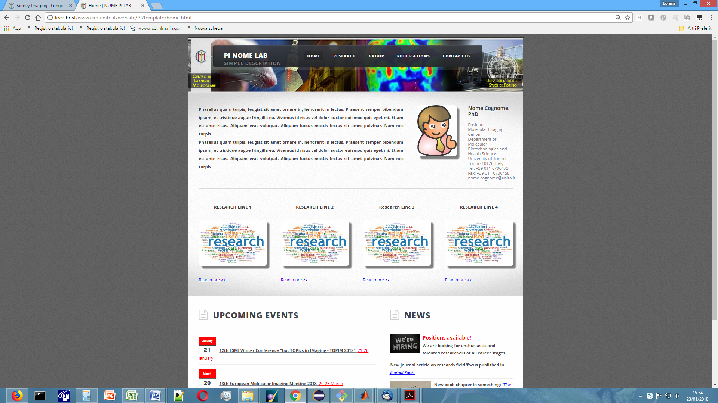

**RESEARCH OVERVIEW**

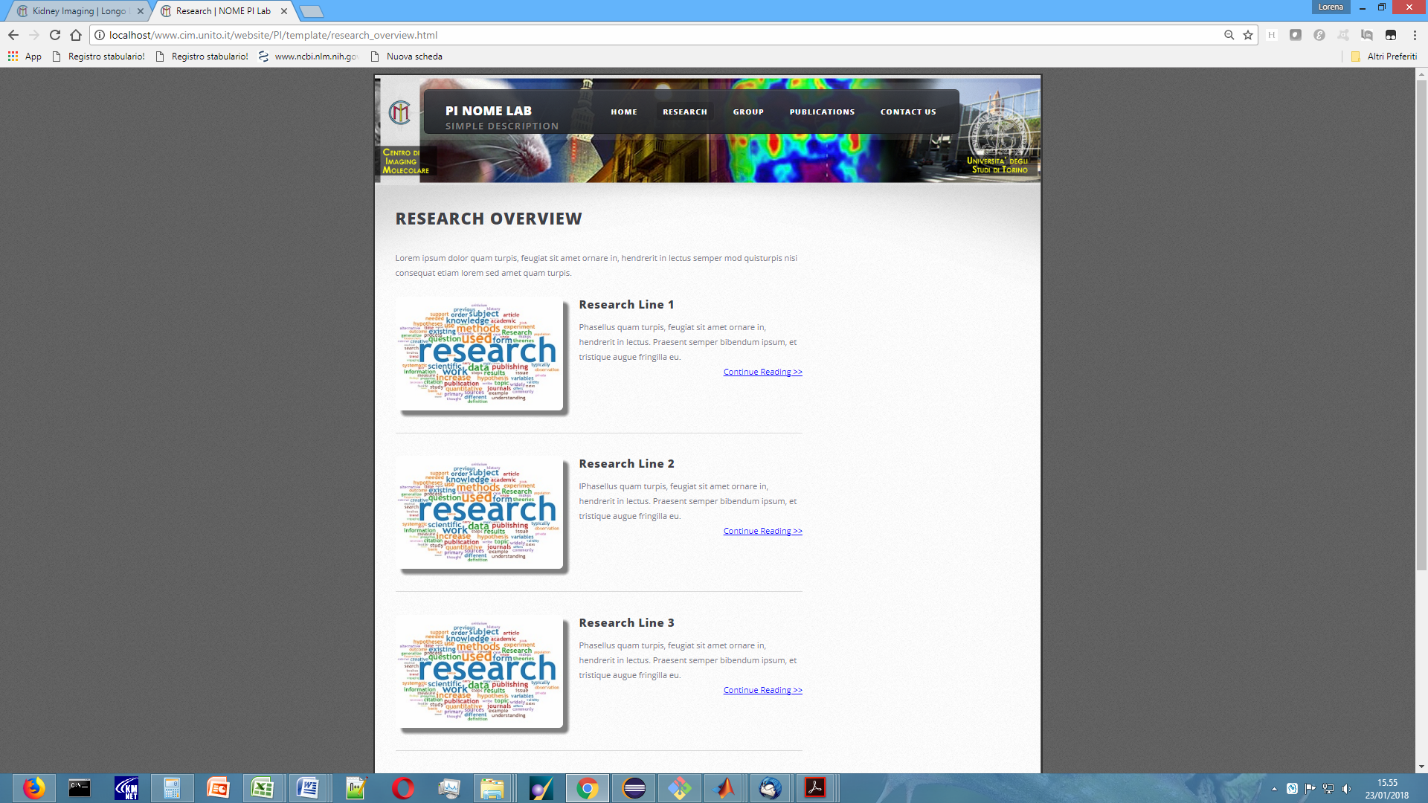

**RESEARCH LINE #1, #2, ...**

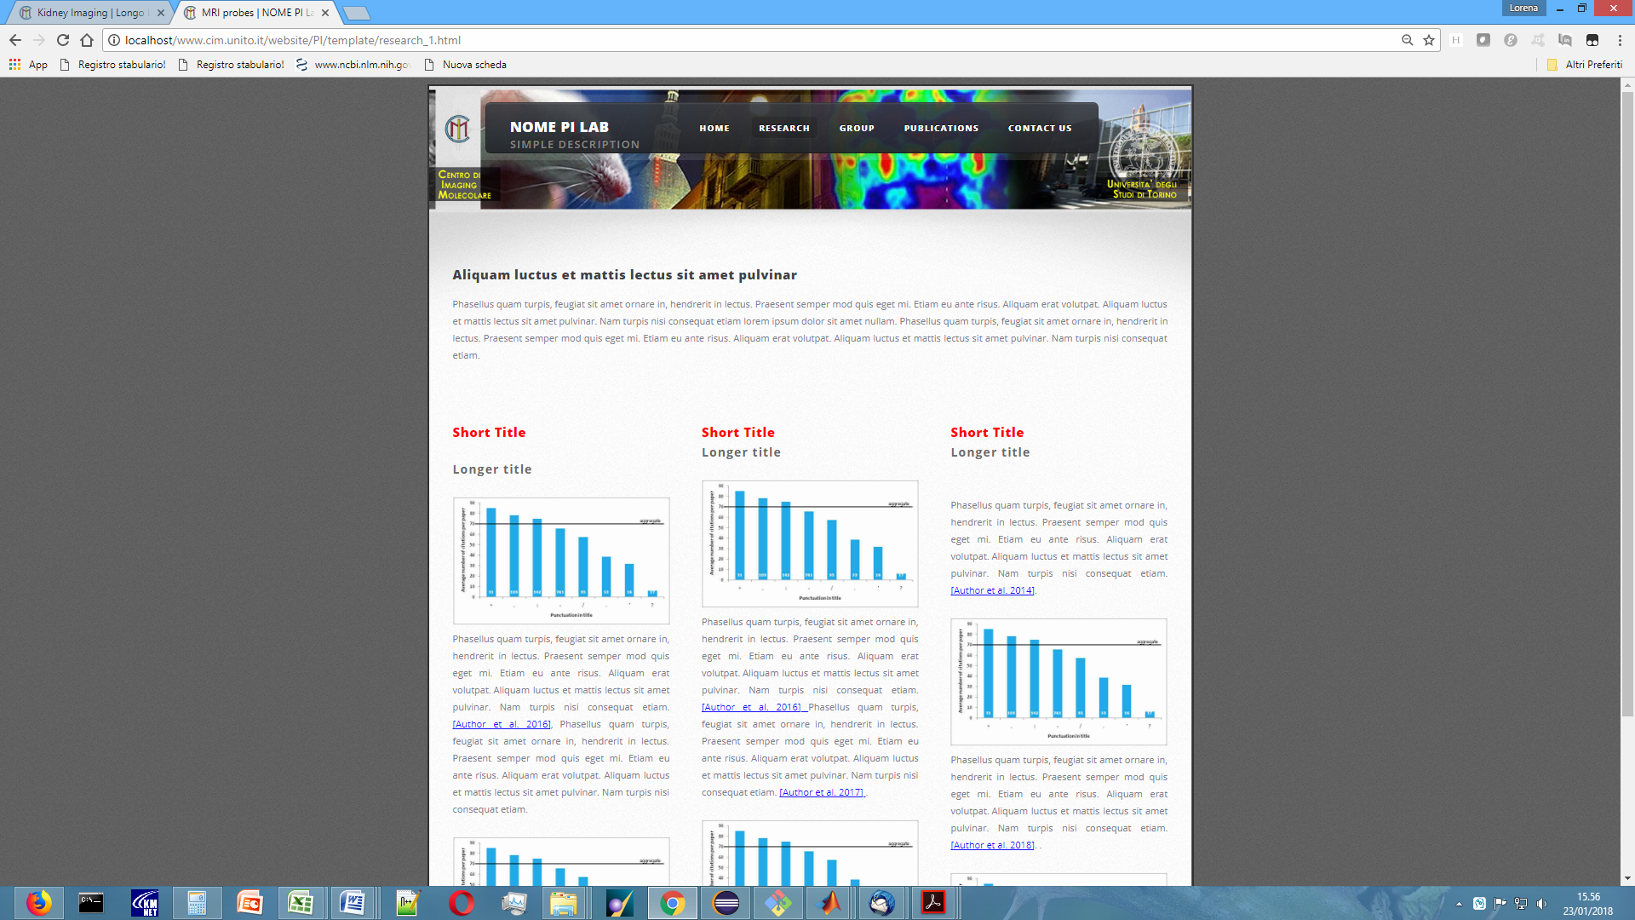

**GROUP**

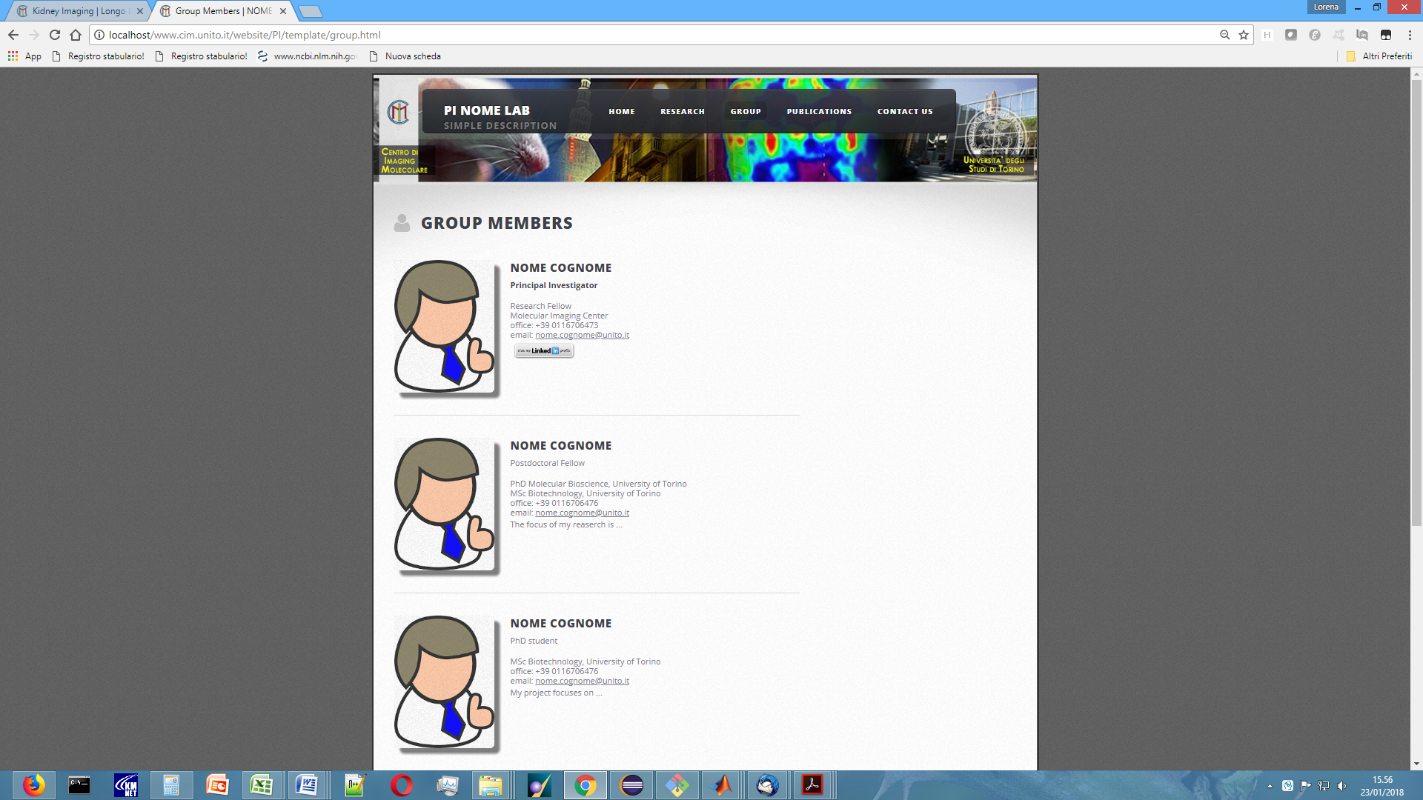

**PUBLICATIONS**

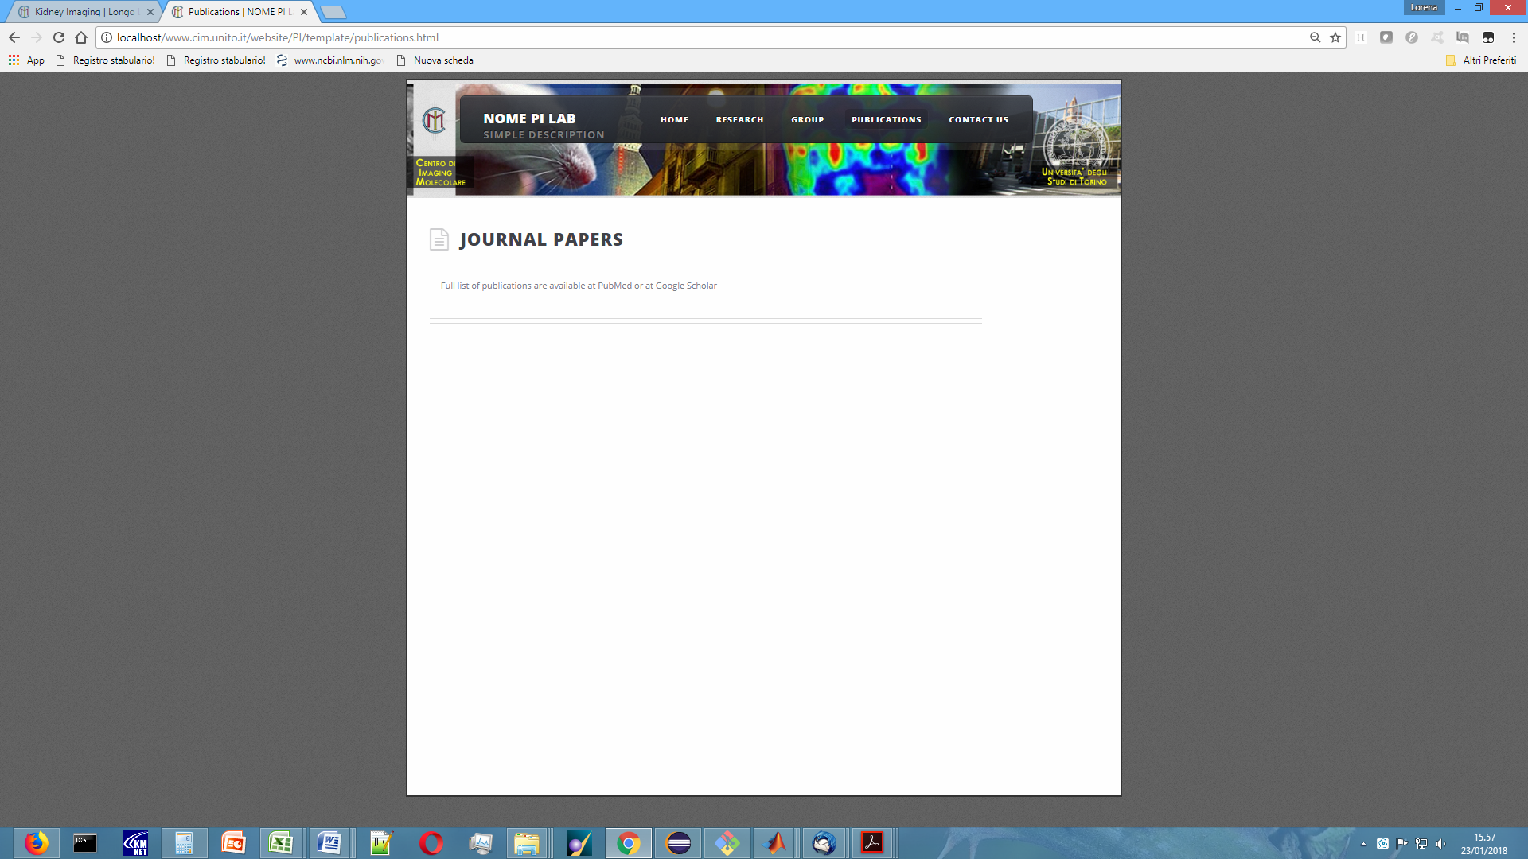

**CONTACT US**

